**Case Study Review**

This assignment was created to discuss the article about ontology for agriculture published 8 years ago at 2nd International Conference on Computing for Sustainable Global Development (Malik et al., 2015). Readers are warmly required to get acquainted with it in advance, since this paper highlights the ontology development approaches described in the article, analysing them with pros and cons using relatively new information and research.

**Ontology development approaches**

If you ask ChatGPT to help you with discussing the article, the AI gives you back the opinion that “the article provides a useful overview of ontology development and its importance in various fields”. In general, we share this view, however, humans are considered to look more critically at the paper in the context of other research over the past few years.

We agree to the proposed *generic ontology* approach for agriculture ontology. According to Bimba at el. (2016), this method is the best for multi-agent systems with a lot of concepts, states, events, processes, actions, etc. But at the same time, Bimba allocates the *domain ontology* as another separated category of ontologies. This type of ontology represents conceptualizations for a specific domain to share documents and information mostly, avoiding misperception amongst members of a domain. From that perspective it is very appropriate for the agriculture area as well.

The Malik’s team ideas are great in the context that 8 years ago there was no existing generic ontology available for the agricultural domain. The problem starts when researchers and developers try to create *exhaustively complex* generic domain ontology for agriculture. It is not the same as establishing the medical ontology for humans, since in this case there is only one biological representative – *homo sapiens*, while agriculture includes hundreds of plant species with many specific diseases, pests and other conditions.

For example, Malik proposes five top classes for the ontology: *Plant*, *Disease*, *Pest*, *Pesticide* and *Fertilizer*. However, there is no hint about different soil quality, for instance, *chernozem*, *loam*, *sand*, etc., not to mention the fact that some soil could be more or less *salty* or *acidic*. The ground type is crucial for most of the plants. Moreover, for such an ancient topic like agriculture it would be very useful to apply some philosophical concepts in ontology. Zheng at el. (2012) mentions that there are 24 agricultural seasons in China. Chinese farmers treat them in a variety of ways depending on the south or the north regions’ locations. Obviously, the reality with seasons and soil types in Finland or Canada is absolutely different. For example, even if China, Finland, and Canada have drones for pesticide spraying, they use different models of drones and different apps, while the technology looks absolutely the same in general. As Zheng underlined, agricultural knowledge involves many sub-domains, including time, space, technologies, market, etc. To build all these layers in a single project would represent a big complex ontology that “makes little sense”.

**Application areas**

The generic ontology for agriculture domain could be used to optimize crop yields, reduce waste, minimize environmental impact, it also could be involved in the production, processing, transportation, distribution of agricultural products, and also for livestock management or agricultural research. Nowadays farmers and other specialists use the AGROVOC resource for some of those tasks. Malik at el. defined AGROVOC as a very popular multilingual thesaurus adapted for more than 40 languages (the number of languages was refreshed according to Mietzsch at el., 2021), but underlined that it is not the ontology. Ontology must include the mutual and logically explainable relationships between the concepts, while thesaurus is just a huge semantic cloud.

According to Lauser at el. (2006), AGROVOC is very suitable for re-engineering into an ontology from scratch. However, there is an alternative approach to large semantic resources, which is an aggregation of smaller ontologies into a larger resource. For instance, The Crop Ontology, AgroPortal, CIARD Ring, etc.

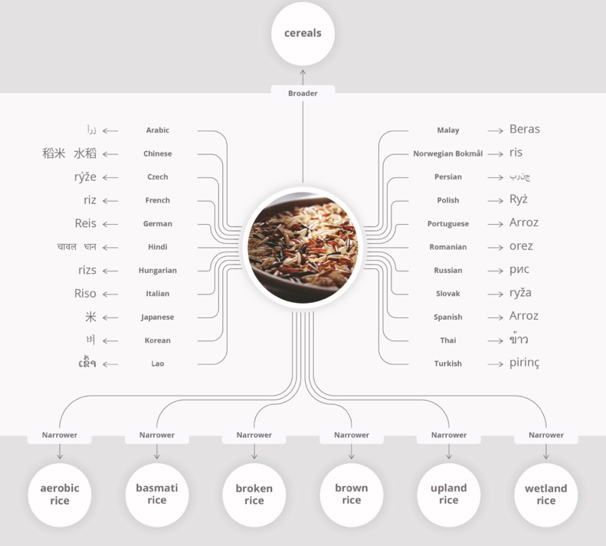Discussing the language aspect, we recommend adding the translation options to the work represented by Malik in Protégé software. Lauser proposes three representation levels, including *concepts*, *terms* and *term variants*. For example, ‘Rice’ in a globally abstract meaning could be a concept, but the ‘Rice’ in its language-specific lexical forms it is the same as ‘Riz’, ‘Arroz’, ‘米 ’, ‘Рис’ or ‘Paddy’ in the other languages. In its turn *Rice* concept could include many narrow species, phenotypes, breeding, etc. with the adaptation for other languages or dialects.

*Picture 1. AGROVOC Concept (Subirats-Coll at el., 2022)*

Lauser also proposed inter-level relations, such as ‘has_lexicalization’ for Concept to Term relation.

Li at el. (2013) researches combining domain ontology and task ontology for the better and practical application in agriculture. In particular, they write about the crop cultivation process. This team uses the AGROVOC information to construct the basic concept relationships through domain ontology. Additionally, they used task ontology to form the framework of crop cultivation standards through analysis of Good Agricultural Practices (GAP) and farming needs. Giving the results of pepper cultivation practices, the team of scientists admitted that for instance, China did not have a clear system rules to guide the crop flow.

As Drury at el. (2019) concludes, the adaptation of these technologies in the academic literature is limited in contrast to complementary domains such as biomedicine. They treat that as an underestimation of using the semantic web technologies in agriculture, since projects in the private sector that apply semantic technologies are often not published in the academic literature.

**Business context**

Ontologies can also be used to support traceability and sustainability initiatives providing a framework for tracking and analyzing the environmental and social impact of agricultural products throughout the supply chain.

In the context of supply chains ontology can help to standardise the terminology and classifications of different crops, products, quality standards to streamline communication and reduce errors and delays.

There is a huge possible territory for applying ontologies beyond agricultural sector. Fensel at el. (2000) proposed three industries for business application of *On-To-Knowledge* European project, which represents an ontology-based tool environment to speed up knowledge management – insurance, telecom, energy – from call-centers to standardization tasks.

The interesting and relatively new example of work in agriculture domain is *AgriOn –* agricultural ontology concept along with the Internet of Things concept of smart farming with near real-time activities (Urkude & Pandey, 2020) This team presents a comprehensive ontology defining the concept of precise agriculture with soil type, soil condition, virus attack, pesticide, field process, crop process etc.

Practically the quality of an ontology depends on its validity, that is why ontology validation and evaluation is a very important task (Walisadeera at el., 2016). We consider this topic in the following chapter.

**Adapting the approaches**

This process includes a few steps to ensure that the ontology is relevant, accurate, effective, and useful. In contrast to Malik’s 7 steps, we propose an alternative way:

1. *Domain Identification.* The main task is to understand the concepts, terminology, relationships, stakeholders, applications inside a specific domain.
2. *Data Gathering.* Involvesliterature reviews, interviews, surveys to identify the up-to-date and already existing concepts that need to be represented in the ontology.
3. *Scope Defining.* To determine the levels of granularity, abstraction, hierarchy, etc., which are appropriate for the domain and real cases.
4. *Ontology* *Development.* On this step it is possible to create the concepts, relationships, guidelines, axioms that define the domain (probably, using the *Protégé* app).
5. *Validation and Evaluation.* It may occur with different tools,involving testing some parts of ontology with evaluation metrics (for instance, precision & recall), field testing, and getting the feedback from users and experts.

There is no mention about validation and evaluation process in the Malik’s paper, however, we suppose it is worth looking at in a little more detail.

Walisadeera at el. (2016) pointed the criteria used for evaluating and assessing the ontologies: *consistency, completeness, conciseness, expandability, sensitiveness.*

Gómez-Pérez (2004) addressed some possible types of errors caused when structuring domain knowledge in taxonomies in an ontology. For example, circularity errors, exhaustive and non-exhaustive class partition errors, redundancy errors, grammatical errors, semantic errors, etc.

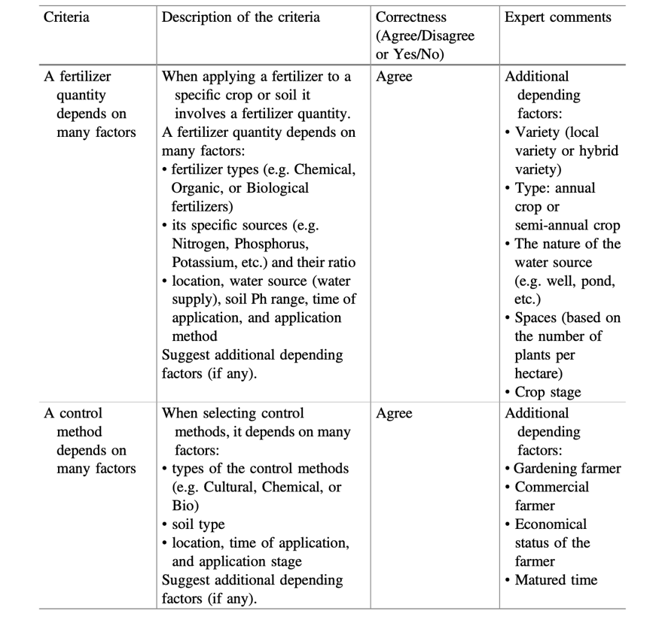

To avoid them the researchers should use one of the core principles of the web data – to push the use of URIs for any concert and sub-concept. According to Berners-Lee (2005), Uniform Resource Identifier (URI) provides a simple and extensible means for identifying a resource (Protégé uses IRI for the same principle).

Walisadeera’s team applies the Delphi method as a research technique to obtain responses from a group of domain experts. It looks very detailed, and we recommend using this approach.

*Table 1. A summary of expert response for some design criteria (Walisadeera at el., 2016)*

Additionally, a web-based tool called OOPS! (Poveda-Villalón at el., 2012) could be also used to detect potential pitfalls in the ontology. It proposes the check-system with three levels of pitfalls: *critical*, *important* and *minor*. For example, *critical* is crucial and it needs to be corrected as soon as possible.

**Conclusion**

The proposed work is definitely clear, useful, with representation of both theoretical and practical approaches. It looks very consistent for a person who has never heard about ontology. In this case the proposed way of creating ontology is obvious and fundamental. Nevertheless, as the team was building ontology from scratch, the work is in preliminary stages. It didn't have a lot of depth, examples of specific practical application or validation and evaluation proofs.

**References**

Malik, N., Sharan, A. & Hijam, D. (2015) March. Ontology development for agriculture domain. In 2015 *2nd International Conference on Computing for Sustainable Global Development* (INDIACom) (pp. 738-742). IEEE.

ChatGPT Feb 13 Version. Available at: chat.openai.com [Accessed 6 Mar 2023]

Bimba, A.T., Idris, N., Al-Hunaiyyan, A., Mahmud, R.B., Abdelaziz, A., Khan, S. & Chang, V. (2016) Towards knowledge modeling and manipulation technologies: A survey. *International Journal of Information Management* 36(6): 857–871.

Zheng, Y.L., He, Q.Y., Ping, Q.I.A.N. & Ze, L.I. (2012) Construction of the ontology-based agricultural knowledge management system. *Journal of Integrative Agriculture*, 11(5), pp.700-709.

Mietzsch, E., Martini, D., Kolshus, K., Turbati, A. & Subirats, I. (2021) How agricultural digital innovation can benefit from semantics: The case of the Agrovoc multilingual thesaurus. *Engineering Proceedings*, 9(1), p.17.

Lauser, B., Sini, M., Liang, A., Keizer, J. & Katz, S. (2006) From AGROVOC to the agricultural ontology service/concept server. An OWL model for creating ontologies in the agricultural domain. *Dublin Core Conference Proceedings*. Dublin Core DCMI.

Subirats-Coll, I., Kolshus, K., Turbati, A., Stellato, A., Mietzsch, E., Martini, D. & Zeng, M., (2022) AGROVOC: The linked data concept hub for food and agriculture. *Computers and Electronics in Agriculture*, 196, p.105965.

Li, D., Kang, L., Cheng, X., Li, D., Ji, L., Wang, K. & Chen, Y. (2013) An ontology-based knowledge representation and implement method for crop cultivation standard. *Mathematical and computer modelling*, 58(3-4), pp.466-473.

Drury, B., Fernandes, R., Moura, M.F. & de Andrade Lopes, A. (2019) A survey of semantic web technology for agriculture. *Information Processing in Agriculture*, 6(4), pp.487-501.

Fensel, D., Harmelen, V. F., Klein, M. & Akkermans, H. (2000) *On-To-Knowledge: Ontology-based Tools for Knowledge Management*. Amsterdam: Free University Amsterdam VUA, Division of Mathematics and Informatics.

Urkude, G. & Pandey, M., 2020. AgriOn: a comprehensive ontology for Green IoT based agriculture. *J Green Eng*, 10(9), pp.7078-7101.

Walisadeera, A.I., Ginige, A. & Wikramanayake, G.N. (2016). Ontology evaluation approaches: a case study from agriculture domain. *Computational Science and Its Applications--ICCSA 2016: 16th International Conference, Beijing, China, July 4-7, 2016, Proceedings*, Part IV 16 (pp. 318-333). Springer International Publishing.

Gómez-Pérez, A.: Ontology evaluation. In: Staab, S., et al. (eds.) (2004) Handbook on Ontologies, Part II, pp. 251–274. Springer, Berlin Heidelberg.

Berners-Lee, T., Fielding, R., Masinter, L. (2005) RFC3986: Uniform Resource Identifier (URI): Generic Syntax. https://tools.ietf.org/html/rfc3986 [Accessed: 12 Mar 2023]

Poveda-Villalón, M., Suárez-Figueroa, M.C., Gómez-Pérez, A. In: ten Teije, A., et al. (eds.) (2012) Validating ontologies with OOPS! EKAW 2012. LNCS, vol. 7603, pp. 267–281. Springer, Heidelberg.